what is javascript ?

javascript is a client side scripting language

javascript is used as a programming language

javascript is used to fast load data on browser

javascript is a case sensitive language.

Javascript provides to block or store content on browser.

Javascript is used to set a behaviour in your application.

Javascript provides to load a loader for nay website.

Javascript is used to print a dynamic date and time in your application.

Javascript is used to store data inside of variables.

Javascript is used to block users and block right click on broswers.

Javascript is used to validate users using forms.

Javascript is most popular client side scripting language.

Javascript is called inside of <body> and <head>.

Javascript is used <script> tag to called.

Javascript provides to store a dynamic data using ..

1. Variable
2. Array
3. String
4. Function
5. Object

Javascript used as programming language its support both POP and OOP base language.

What is POP ?

POP is procedural base language

1. Variable
2. Array
3. String
4. Function
5. Object

What is OOP ?

OOP is object oriented programming language

1. Class
2. Object
3. Inheritance
4. Constructor
5. Desctructure
6. encapsulation

**Javascript advantage ?**

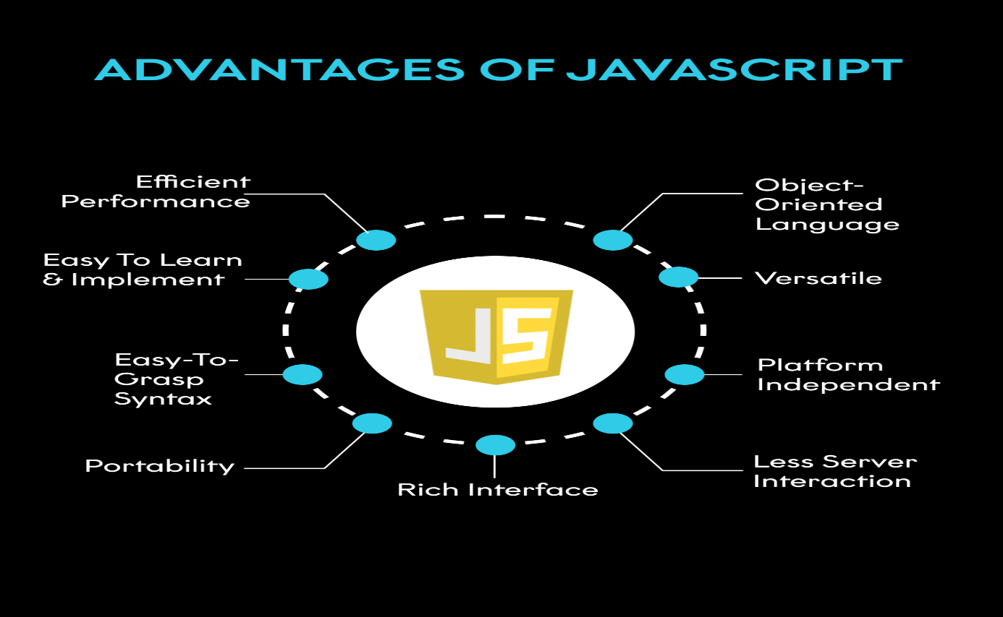

**How to call javascript ?**

   <script type="text/javascript">

        alert('Hi i am just loading javascript please click OK')

        window.location='https://www.flipkart.com';

    </script>

**Javascript operator :**

Operand some actions there we used operator.

Types of operator

1. airthmatic operator

eg: + , - , * , / , % etc

1. assignment operator

eg: =, +=, -=, *= , %= etc

1. comparision operator

eg: ==,=== ,!= , > , < , >= , <= etc

1. logical operator operator

eg: and && , or || , ! not etc

1. increment/decrement operator

eg: ++ , -- etc

i++ post increment

i—post decrement

++i pre increment

--i pre decerement

1. ternary operator

eg: ?: etc

1. string concatenate operator

eg: + etc

**javascript variable ?**

variable is just like container where we store an information about data i.e called a variables.

Or

Variable stores information about data i.e called a variable.

In javascript variable assign with var or let symbol.

Eg: var a=10;

var b=10.56565;

let name=”brijesh”;

var name=’hi I am parth’;

**difference b/w let and var ?**

**var :** defined or access any variable globally.

**var :** defined or access any variable globally.